Course Assignment – Square Eyes

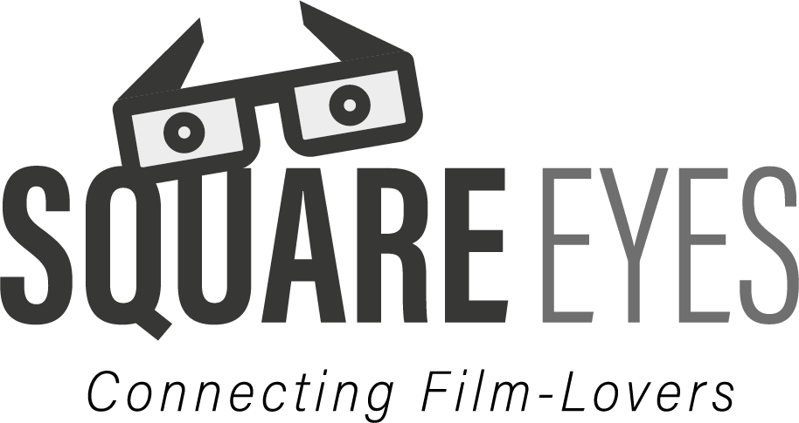

# Approach

I Picked the task “Square eyes” as I am very interested in movies, and felt it was an appropriate choice. I did the same design task last year, and decided to do it once more this year, as I would check on what I’d do differently and where I’ve improved.

I drew inspiration from Netflix and Viaplay primarily, but I also took som inspiration from IMDB.

For the colour palette, I used <https://coolors.co> to pick out a dark grey colour that I used as a fundament for the background. Seeing as most, if not all streaming websites utilize a dark theme, I felt It would be appropriate to do so as well. The grey colouring is easy on the eye.

I complimented the dark colouring with light egg-shell colour for most of the UI components, and used a yellow colour to grab attention and for CTA-elements. The usage of light colours is in large part to avoid plagiarizing brands like Netflix, viaplay, HBO, Amazon etc and making it a bit more unique. The and subtle colours also have an intended effect of giving the page a more neutral look – And yellow is very seldom used as a secondary colour among the streaming giants.

# Challenges

I encountered a few challenges – Mostly bad time management from my part, but I was also stuck at choosing a style, coloration and typefaces for a long time as I didn’t really want to commit to a specific style, only to regret it later on. I ended up using coolors to find a nice colour scheme and ChatGPT to recommend me fonts that could work well for a movie web page – so I didn’t have to scroll through hundreds fonts in Figma.

# Achievements

I am proud of my final design and I feel that it is sleek and has consistency in all frames. I feel like I’ve learned a lot in regard to grids and features in figma. I deliberately made the design simple and did not attempt to include tons of gimmicky features or figma prototype automations but rather focused on the essentials. I think the contrast between background and paragraph text works well, although its very close to being to little contrast.

# Conclusion

I feel like I’ve learned a lot, and I’ve had a lot of fun working on this project. Next time I will for sure collaborate more with fellow students to get input on my project and it’s shortcomings continuously.

# Note

Other than the provided resources, the external assets I’ve used have been:

* <https://www.figma.com/community/file/839558611085349133/social-icons> (social icons)
* Fontawesome.com (Other icons, buttons and some text)
* Pictures from IMDb (“Video preview” on browse-page, “trailer” on video page)
* Icons from Vipps, Paypal, Visa, MasterCard

Timeline was generated by ChatGPT